Experiment No. 1.1
Generation and Classification of Continuous-Time and Discrete-Time Signals
OBJECTIVE:
- To generate and visualize basic continuous-time signals such as unit step, unit impulse, ramp, sinusoidal, and exponential signals.
- To generate and visualize basic discrete-time signals and analyze their amplitude and time index characteristics.
- To generate and classify continuous-time and discrete-time signals as periodic or aperiodic based on their periodicity characteristics
Experimental Procedure :
1. Define a continuous time vector with a sufficiently small simulation interval.
2. Generate unit impulse, unit step, ramp, exponential and sinusoidal signals.
3. Plot each waveform against time using suitable amplitude and time scales.
4. Measure amplitude, frequency and period wherever applicable.
5. Compare the simulated waveform with its theoretical expression.
6. Record observations and justify the signal characteristics.
MATLAB Coding:
% Experiment 1: Generation of Continuous-Time Signals
clc; clear; close all;
t = -1:0.001:1;
A = 2; f0 = 5; a = 1;
imp = double(abs(t)<0.0005);
step=double(t>0);
ramp = t.*step;
expSig = exp(-a*t).*step;
sinSig = A*sin(2*pi*f0*t);
figure;
subplot(3,2,1); plot(t,imp); grid on; title('Unit Impulse'); xlabel('t');ylabel('Amplitude'); subplot(3,2,2); plot(t,step); grid on; title('Unit Step'); xlabel('t'); ylabel('Amplitude'); subplot(3,2,3); plot(t,ramp); grid on; title('Ramp'); xlabel('t'); ylabel('Amplitude'); subplot(3,2,4); plot(t,expSig); grid on; title('Exponential'); xlabel('t'); ylabel('Amplitude'); subplot(3,2,5); plot(t,sinSig); grid on; title('Sinusoidal'); xlabel('t'); ylabel('Amplitude');
OUTPUT:
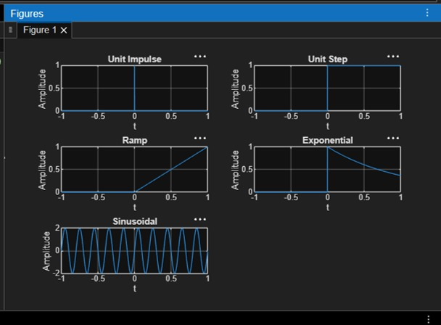
RESULT:
This test case validates that the signal generator can produce a sinusoidal waveform with the specified frequency, amplitude, and phase shift.

EXPERIMENT:1.2
To generate and visualize basic discrete-time signals and analyze their amplitude and time-index characteristics.
Expected Outcomes:
• Generate correctly indexed discrete-time sequences.
• Plot sequences using stem representation.
• Identify discrete-time waveform characteristics and periodicity.
Experimental Procedure:
1. Define the integer sample index n. Qualitative match
2. Generate unit impulse, unit step, ramp, exponential and sinusoidal sequences.
3. Display each sequence using a stem plot.
4. Determine sample amplitudes and period where applicable.
5. Classify the sequence as periodic/non-periodic and even/odd wherever applicable.
6. Compare the generated samples with theoretical values and record observations.
MATLAB Coding:
% Experiment 2: Generation of Discrete-Time Signals
clc; clear; close all;
n = -20:20;
A = 2; f0 = 0.1; a = 0.1;
imp = double(n==0);
step = double(n>=0);
ramp = n.*step;
expSig = (0.8).^n .* step;
sinSig = A*sin(2*pi*f0*n);
figure;
subplot(3,2,1); stem(n,imp,'filled'); grid on; title('Unit Impulse');
subplot(3,2,2); stem(n,step,'filled'); grid on; title('Unit Step');
subplot(3,2,3); stem(n,ramp,'filled'); grid on; title('Ramp');
subplot(3,2,4); stem(n,expSig,'filled'); grid on; title('Exponential');
subplot(3,2,5); stem(n,sinSig,'filled'); grid on; title('Discrete Sinusoid'); xlabel('n');
OUTPUT:
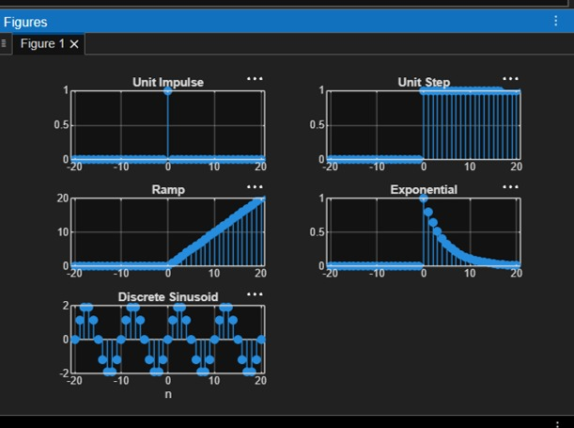
RESULT:
This test case validates that the signal generator can accurately produce a discrete-time unit impulse signal at a specified index, which is essential for analyzing the response of discrete time systems.

EXPERIMENT:2.1
Signal Operations and Transformations
OBJECTIVE:
- To perform amplitude scaling and time scaling of continuous-time and discrete-time signals and analyze their effects on signal characteristics.
- To perform time shifting and time reversal of continuous-time and discrete-time signals and analyze the resulting transformations.
- To perform addition and multiplication of two discrete-time sequences and analyze the resulting signal characteristics.
Experimental Procedure:
1. Generate the base signal x(t) = sin(2π5t).
2. Apply amplitude scaling using A = 2.
3. Apply time compression using x(2t).
4. Apply time expansion using x(t/2).
5. Plot the original and transformed signals using common axes.
6. Measure the amplitude and period of the transformed signals.
7. Compare the measured results with the theoretical scaling relationships.
MATLAB CODING:
% Experiment 2(i): Amplitude and Time Scaling
clc; clear; close all;
t = -1:0.001:1;
x = sin(2*pi*5*t);
yA = 2*x;
yC = sin(2*pi*5*(2*t));
yE = sin(2*pi*5*(t/2));
figure;
subplot(2,2,1); plot(t,x); grid on;
title('Original x(t)'); xlabel('Time (s)'); ylabel('Amplitude');
subplot(2,2,2); plot(t,yA); grid on;
title('Amplitude Scaling: 2x(t)'); xlabel('Time (s)'); ylabel('Amplitude');
subplot(2,2,3); plot(t,yC); grid on;
title('Time Compression: x(2t)'); xlabel('Time (s)'); ylabel('Amplitude'); subplot(2,2,4); plot(t,yE); grid on;
title('Time Expansion: x(t/2)'); xlabel('Time (s)'); ylabel('Amplitude');
OUTPUT:
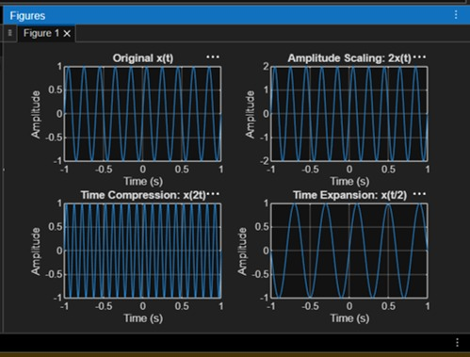
RESULT:
• Periodic Signal: The sinusoidal signal repeats itself at regular intervals, making it periodic.
• Aperiodic Signal: The exponentially decaying signal does not repeat, showcasing that it is aperiodic.

EXPERIMENT:2.3
To perform addition and multiplication of two discrete-time sequences and analyze the resulting signal characteristics
Expected Outcomes :
Obtain correct sum and product sequences.
• Preserve the common sample index for aligned sequences.
• Verify representative output samples numerically.
• Interpret how addition and multiplication change sequence values.
Experimental Procedure :
1. Define the sample index n.
2. Enter x[n] and y[n] with aligned indices.
3. Compute the sum sequence.
4. Compute the product sequence using pointwise multiplication.
5. Plot the input and resulting sequences using stem plots.
6. Compare the calculated samples with manual/theoretical results.
MATLAB CODING:
% Experiment 2(iii):
Addition and Multiplication of Two Sequences
clc; clear; close all;
n = 0:2;
x = [1 2 1];
y = [1 1 2];
zSum = x + y;
zProd = x .* y;
figure;
subplot(2,2,1); stem(n,x,'filled'); grid on;
title('x[n]'); xlabel('n'); ylabel('Amplitude');
subplot(2,2,2); stem(n,y,'filled'); grid on;
title('y[n]'); xlabel('n'); ylabel('Amplitude');
subplot(2,2,3); stem(n,zSum,'filled'); grid on;
title('Addition x[n]+y[n]'); xlabel('n'); ylabel('Amplitude');
subplot(2,2,4); stem(n,zProd,'filled'); grid on;
title('Multiplication x[n]y[n]'); xlabel('n'); ylabel('Amplitude');
OUTPUT:
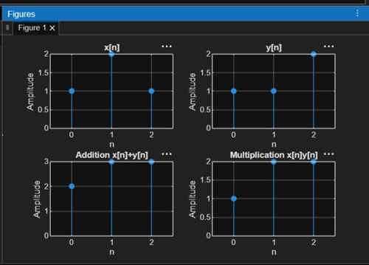
RESULT:
Scaling affects amplitude or time axis accordingly.

EXPERIMENT:3.1
Energy and Power Analysis of Signals
OBJECTIVE:
- To calculate the energy and average power of given continuous-time and discrete time signals and classify them as energy signals, power signals, or neither based on their energy and power characteristics.
Experimental Procedure:
1. Define the time vector and generate the selected signals.
2. Compute the squared magnitude of each signal.
3. Numerically integrate over a sufficiently large interval for energy.
4. Compute average power over an interval containing several periods for the periodic signal.
5. Compare numerical results with analytical expectations.
6. Classify the signals and record observations.
MATLAB CODING:
% Experiment 3:
Energy and Power Analysis
clc; clear; close all;
dt = 0.001;
t = 0:dt:5;
xE = exp(-t);
xP = sin(2*pi*5*t);
E_num = trapz(t,abs(xE).^2);
T0 = 1/5;
idx = t <= 2;
P_num = (1/(t(find(idx,1,'last'))-t(1))) * ...
trapz(t(idx),abs(xP(idx)).^2);
figure;
subplot(2,1,1);
plot(t,xE); grid on;
title('Energy Signal e^{-t}u(t)');
xlabel('Time (s)'); ylabel('Amplitude');
subplot(2,1,2); plot(t,xP); grid on;
title('Power Signal sin(2pi5t)'); xlabel('Time (s)'); ylabel('Amplitude'); fprintf('Numerical energy = %g\n',E_num);
fprintf('Numerical average power = %g\n',P_num);
OUTPUT:
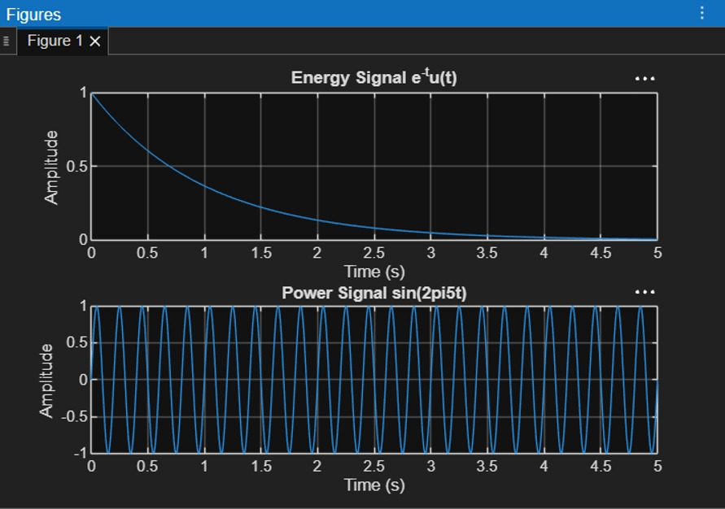
RESULT:
Two discrete-time sequences were generated and their addition and point-wise multiplication were performed successfully using MATLAB. The resulting sequences were displayed using stem plots, illustrating basic operations on discrete-time signals.

EXPERIMENT:4.1
Verification of System Properties: Linearity, Time Invariance, Causality and Stability
Objective:
- To verify the linearity and time-invariance properties of continuous-time and discrete-time systems using suitable input signals and system responses.
- To analyze and classify continuous-time and discrete-time systems as causal or non-causal based on their input-output relationships.
- To analyze and classify systems as memoryless or dynamic based on their dependence on present and past input values.
EXPERIMENTAL PROCEDURE:
- Select a representative CT or DT system.
- Generate two independent test inputs.
- Compute the individual system outputs.
- Form a combined input and compare its system output with the corresponding linear combination of outputs.
- Delay the input by t0 and compare the system response with the correspondingly delayed original output.
- Calculate numerical differences and classify the system.
MATLAB CODING:
% Experiment 11: Linearity and Time Invariance
clc; clear; close all;
t = -1:0.001:1;
x1 = sin(2*pi*5*t); x2 = cos(2*pi*5*t);
a = 2; b = 3; t0 = 0.2;
T = @(x) 2*x;
lhs = T(a*x1+b*x2);
rhs = a*T(x1)+b*T(x2);
linError = max(abs(lhs-rhs));
xDelay = sin(2*pi*5*(t-t0));
lhsTI = T(xDelay);
rhsTI = T(x1);
rhsTIshift = interp1(t,rhsTI,t-t0,'linear',0);
tiError = max(abs(lhsTI-rhsTIshift));
figure;
subplot(2,1,1); plot(t,lhs-rhs); grid on; title('Linearity Error');
subplot(2,1,2); plot(t,lhsTI-rhsTIshift); grid on; title('Time-Invariance Error'); fprintf('Linearity error = %g\n',linError);
fprintf('Time-invariance error = %g\n',tiError);
OUTPUT:
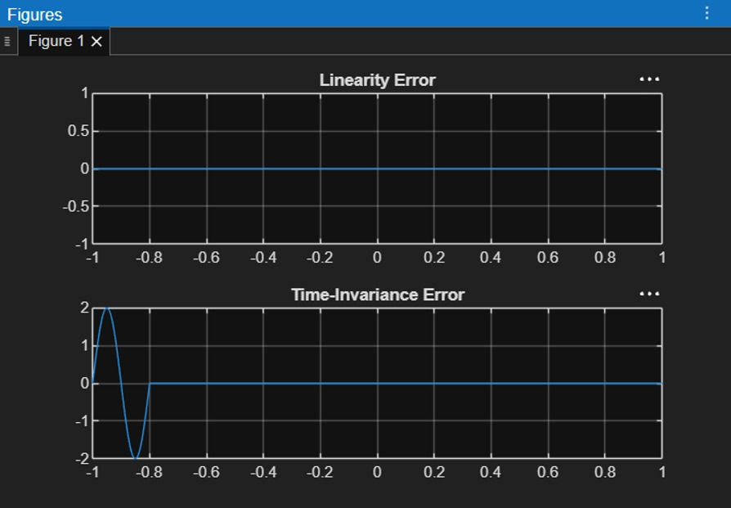
RESULT:
The discrete-time system y(n)=x(n)+x(n−1) was implemented using MATLAB. The output sequence was obtained by combining the present and previous input samples, and the input and output signals were displayed using stem plots.

